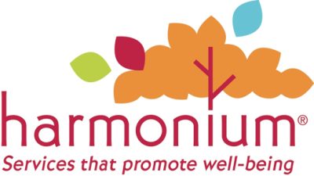

Feedback Form
Harmonium is committed to providing services that promote well being. We design programs tailored to meet the needs of each of the communities we serve. We are interested in your feedback as a part of our continuous improvement.

Date:
Program Location:

1. Was the environment welcoming? |  | YES |  |  | NO
2. Did you find the staff knowledgeable regarding your request? |  | YES |  |  | NO
3. Were your needs met? |  | YES |  |  | NO
4. Did you find the staff courteous and respectful? |  | YES |  |  | NO

5. I would like to see Harmonium offer…

6. Additional Comments:

OPTIONAL INFORMATION

Name:
Contact Information:

Please place this form in the comment box located at your program site… or

Provide feedback confidentially online at Harmoniumsd.org through our feedback form located under the Contacts menu on the main page.

